Social Commentary and Satire Syllabus
Ms. Fitzell-Stevens
Social Commentary & Satire
Room 105
Office Hours: Monday 3-3:40pm or by appointment.
Contact: sfitzell@hps.holyoke.ma.us
Website: fitzellenglish.weebly.com
Course Overview

Part of being a responsible citizen of the world is to keep informed on current issues and be able to look through a critical lens to try to find solutions. In this class, students will read about current events and report their findings to the group. Students will watch and discuss documentaries on the hot topics of health, education, and nature, such as Supersize Me, Bully, and Blackfish, and will watch films that connect to these issues. After forming a good base knowledge, students will then examine the world around them through the critical lens of satire. Students will focus on light-hearted through the use of The Onion, The Simpsons, and The Daily Show, and dark satire, specifically dystopian, through readings and film. Students will also examine art and poetry as means of social criticism.

Student Responsibilities
- Students assignments will consist of:
  - weekly current event reports, both written and oral
  - class discussions
  - essays
  - quizzes
  - maintaining notes
  - creative projects

Student Evaluation
Exams/Analytical Essays/Projects - 35%
Quizzes/Timed Writing - 20%
Homework - 20%
CW/Discussions/Seminars - 25%

First Homework Assignment:
Read & annotate the article about the artist Pablo Picasso and his engagement in activism on the back of this syllabus.
- What influenced him to make a political statement?

- What was going on Picasso's life at this time?

- What impact could his earlier work, The Dream and Lie of Franco, have had on his decision to create Guernica?

...Picasso's commitment to the cause

Until the Spanish Civil War broke out in 1936, Picasso had never shown any real interest in politics. But as was the case for many artists and intellectuals in Europe at the time, the threat of fascism fueled in Picasso a passionate opposition to the precepts and atrocities of war. His activism took the form of financial and personal support for the Republican cause, but he was reluctant to mix politics and art.
In November of 1936, Franco launched an all-out air attack on Madrid. When the Museum del Prado itself was bombarded by Franco's artillery, the museum's entire collection had to be removed from the city for safety. Infuriated by the wanton destruction, he accepted the role of Honorary Director-in-Exile of the Prado and became a spokesman of the Republican government in its efforts to publicize Franco's desecration of Spain's artistic heritage.
Picasso also made his condemnation of Franco and the Spanish situation known in a series of bitterly satirical illustrations accompanied by his own prose poem, The Dream and Lie of Franco. The eighteen panels of caricature-like etchings were designed as postcards to be sold at the Spanish Pavilion of the 1937 World Fair to raise money for the Republican cause. "This is a time in Picasso's life and career when he is not only involved in a broader way with political events," says art historian, Patricia Failing, "but also does something very unusual, which is to produce a work specifically for propagandistic and fundraising purposes."
Franco had portrayed himself to the Spanish people as a champion of traditional Spanish culture. But in Dream and Lie Picasso exposes this claim as a grotesque deceit. "And throughout the whole series, Picasso manages this evil little character of a polyp in a very theatrical way," adds Failing, "like a character on a stage that he outfits with various hats and props, and thereby suggests relationships with the Catholic clergy, with art historical traditions, with the traditions of Spanish royalty - basically relationships with the elements of Spanish culture that General Franco was claiming in his campaign to win the hearts of the Spanish people."
Picasso's etchings show Franco as a monstrosity masquerading as tradition, an enemy of the arts, an oppressor of workers and peasants and of creative energy and freedom, and a murderer of Spanish women and children. Although many of the images Picasso used in Dream and Lie are reminiscent of his earlier works, the distorted figures portraying Franco as an "evil-omened polyp" were clearly meant to represent the evil faces of the fascist dictator. "There's an element of caricature, an element of obviousness. There's an element of burlesque in The Dream and Lie of Franco etchings that you don't find in his other work, and you certainly don't find any kind of direct parallel in the Guernica painting."
The last four drawings of the series most closely express what the language of his poetry describes:
...cries of children cries of women cries of birds cries of flowers cries of timbers and of stones cries of bricks cries of furniture of beds of chains of curtains of pots and of papers cries of odors which claw at one another cries of smoke pricking the shoulder of cries...

"Picasso's Commitment to the Cause." PBS. PBS, n.d. Web. 23 Aug. 2014.

Name: _______________________________________________ Date: _____________ Block: _____________
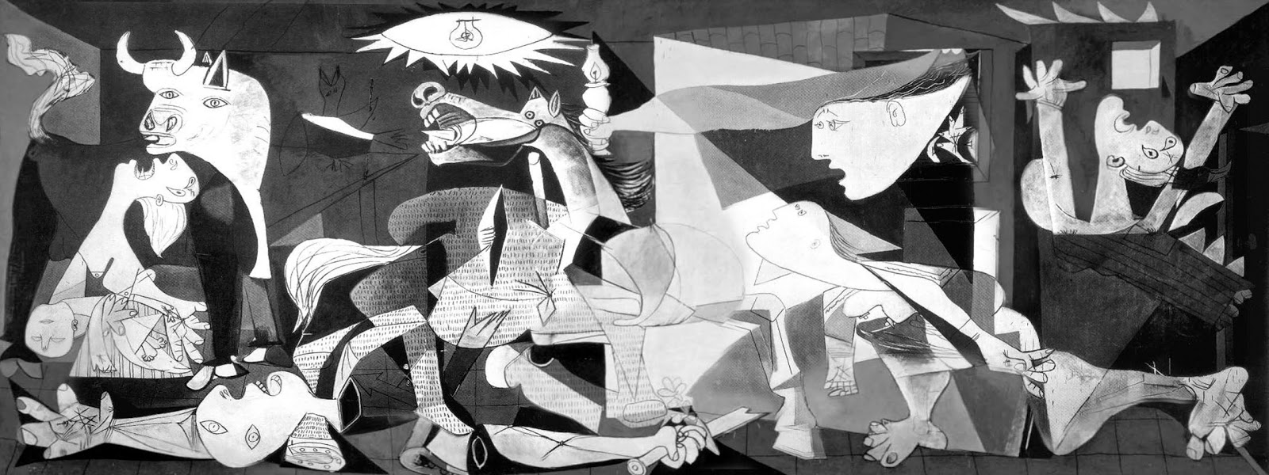
- Why do you think Picasso chose the color, lines and shapes that he did?
- How do these visual elements contribute to the strength of the political message?
- What figures did he include and how did he depict them?
- What decisions must he have made when including those figures (for example, why include a mother and child? a dying soldier? a horse? a bull?)
- How might these figures be symbolic to Picasso both personally and politically?
the tension between art and politics

From an interview with art historian, Patricia Failing:
"One reason Guernica is considered a treasure in terms of art history is that it seemed to provide a bridge between what were considered by some to be antithetical poles: the idea of making an effective political statement and an effective artistic statement at the same time. And this is certainly one of the achievements of the Guernica project, that it was a third space between those two antithetical poles."
"A lot of artists, who looked up to Picasso as the exemplar of Modernist practice in painting, were interested very much in being Modernists on the one hand, and still very concerned about larger political events and the larger political arena in which they could act as artists. You can find many attempts to bring these two concerns together into the same body of work, to be really expressive and exploratory in formal terms and still be able to make a very heartfelt political statement. And to find that the great master of Modernism was able to accomplish this goal somehow - the mere fact that this kind of resolution might be possible - is what had such an enormous effect on artists in the twentieth century."
"Guernica betrays the stereotype of the Modern as the incredibly new and the incredibly, let's say, divorced from tradition, from academic practice. Because it's a painting that you don't necessarily associate with Modernism, and yet it makes an extremely important and extremely evocative Modernist statement at the same time. It did something that an academic painter would have loved to do, which is to take a very traditional theme and make it modern and make it relevant to a new time and a new audience and a new sensibility. That's a pretty big accomplishment."
"There was, of course, a great deal of argument about whether or not it was really as effective a political statement as it could have been if it had been more accessible, if it had been more traditional. And also whether it was really the strongest artistic statement it could have been if it weren't so tied up with a specific political agenda."
"When the painting was on tour around the world, there was a great deal of interest on the part of Communist Party members and Communist intellectuals about whether or not this painting would be able to communicate with anybody of the proletarian or worker class. And so you find that there was a lot of testimony collected over the years from people of the working class who saw Guernica. And they responded to it very powerfully, found that they were really just awestruck by this particular painting. It did seem to have an effect on people who you wouldn't think very likely to react in a positive way to this kind of elitist painting."
"The controversy about whether or not this particular painting could really be an effective political tool never leaves the painting. Picasso himself later on said that painting is not for decorating apartments; it has a much broader social importance. And I think partly the tour was about finding confirmation of that belief."

"The Tension Between Art and Politics." PBS. PBS, n.d. Web. 23 Aug. 2014.

